WIPRO NGA Program – DWS
Capstone Project Presentation – 4th September 2025

Project Title: Add a Launch Condition: Restrict installation to certain OS versions or hardware.

Presented by:
Krishna Verma
User id : 34851
Email : kv979539g@gmail.com

Introduction & Project Objective
This project demonstrates creating a restricted software installer that uses a launch condition to ensure an application is only installed on a specific OS. The two-step process, using an application re-packager and an installer tool, prevents compatibility issues and reduces support overhead. The final product is a reliable package that validates the system before installation.
What is Application Repackaging?
Application repackaging converts an original software installer into a new, standardized package like an MSI.
It works by capturing all system changes made during a clean installation. This new package is highly customizable, enabling silent installations and simplifying large-scale software deployment for administrators.

Benefits of Repackaging
- Standardization: Repackaging converts various installation formats into a single, uniform standard like MSI, which simplifies software management and large-scale deployment by providing a consistent installation experience across applications.
- Customization: It allows for extensive modifications to the original installation, such as adding or removing components and pre-configuring settings without needing the source code.
- Troubleshooting: By creating a detailed record of an application's system changes, repackaging makes it easier to troubleshoot issues. It also allows for the implementation of launch conditions to prevent installation on unsupported systems, proactively ensuring compatibility.
Prerequisites
- A clean virtual machine.
- Advanced Installer Package.
- The application to be repackaged (Cloudflare WARP).

Minimum System Requirements
- CPU: A Core 2 class processor or equivalent.
- RAM: At least 1 GB of RAM.
- Storage: A minimum of 2 GB of free hard drive space.
- Display: Minimum supported screen resolution is 1366x768.
- Operating System: Advanced Installer requires Windows 10 or newer.
Workflow Diagram
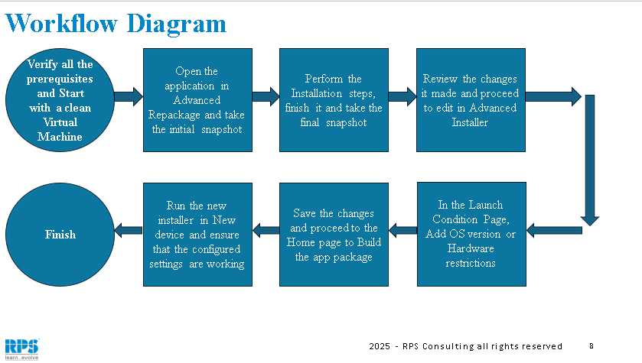
Steps: -
1. Initial Setup and Repackaging
- Create a folder to save your repackaged MSI file.

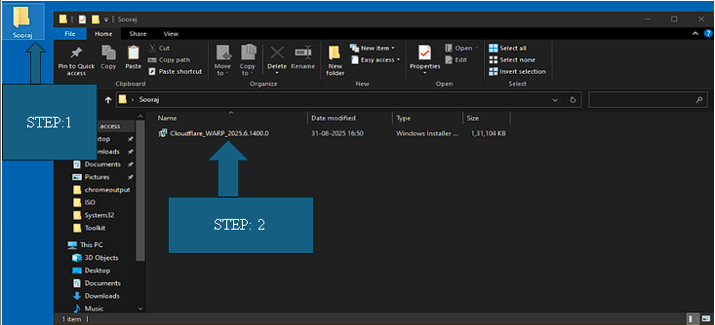
- Open the application repackaging tool.
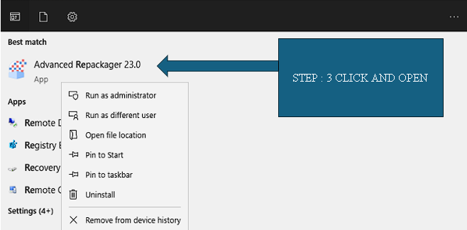
- Click "Capture Setup," select the MSI file to repackage, and provide a name for the output.
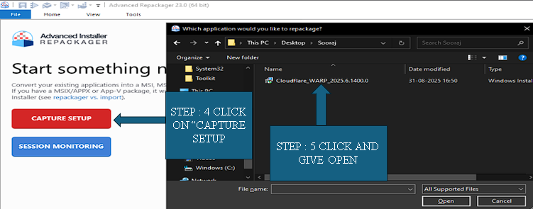
- Click "Start Local" to begin the capture process and save the MSI file.
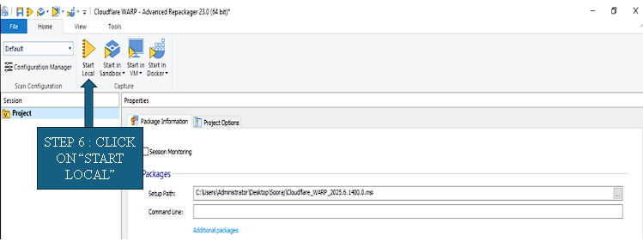

- A pop-up will appear; click "Ignore" and wait until the repackaging is successful.

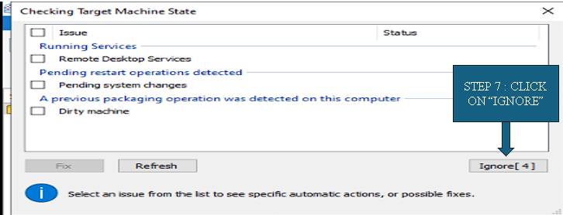

- Another pop-up to install the MSI will appear; click "Next" and then "Install".

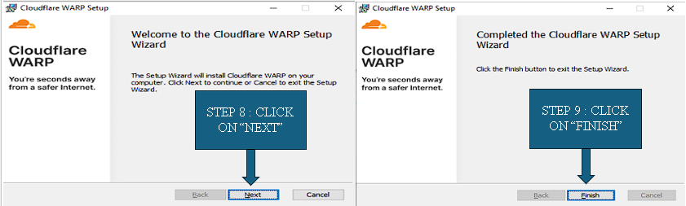

- Click "OK" when the "Are you ready to proceed?" pop-up appears.

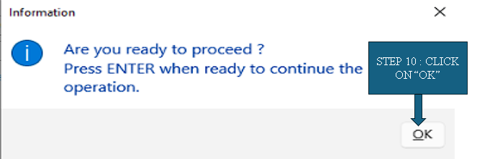
- Wait until the operation is complete and successful.

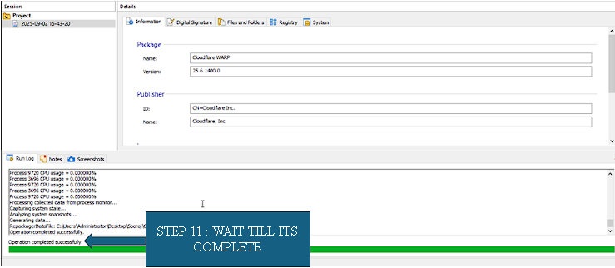
- Click "Open Advanced Installer" and import the repackaged results to import the files and folders of the application.

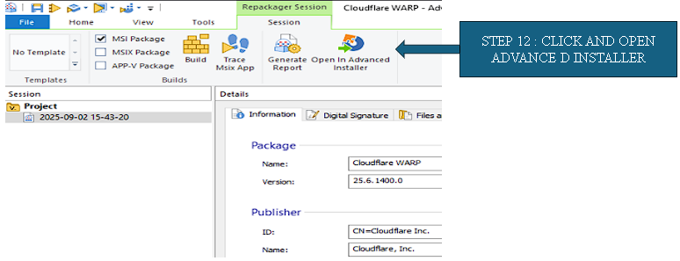
2. Configuring the Launch Condition
- Scroll down to and click "Launch Conditions".

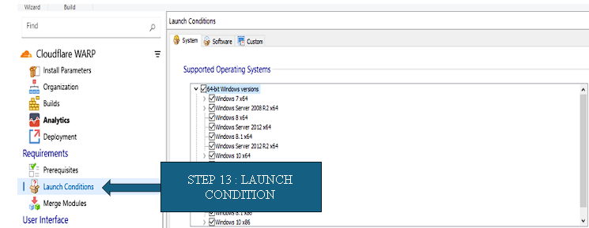
- Under the System Software category, unselect the default "Any Windows Version" option and select the specific OS versions you want to allow, such as Windows Server 2022 x64 and Windows Server x64.

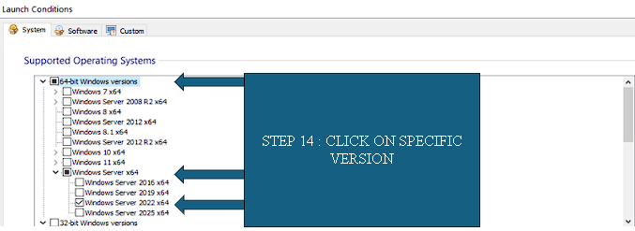
- Go to "Product Details" and then click "Build".

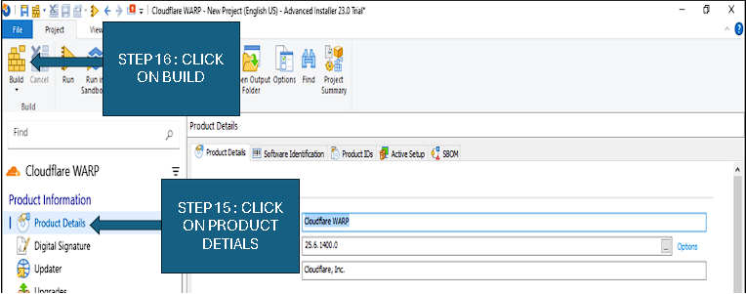

- A pop-up will appear; click "Continue".

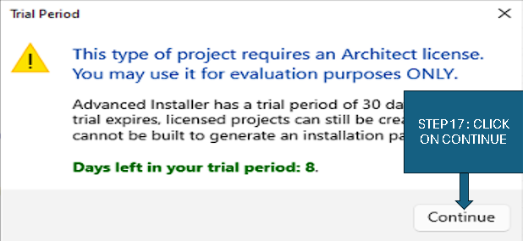
- Save the final MSI file in your folder and wait until it is successfully built.

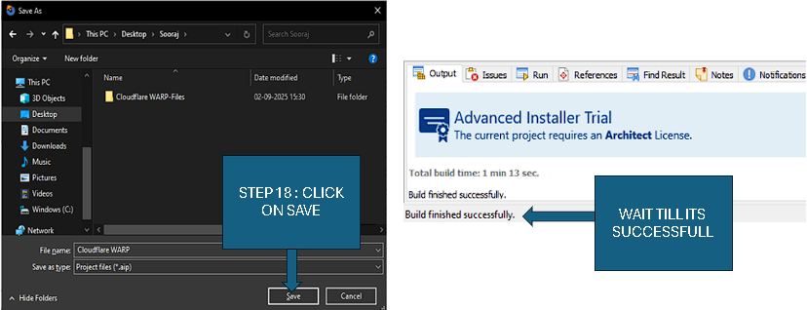

- Uninstall the MSI file you just built.
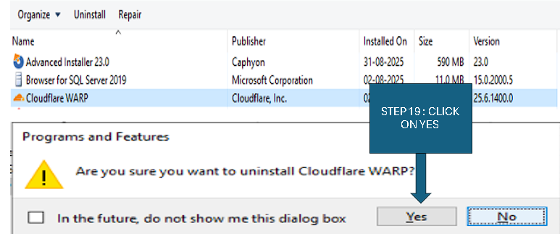
3. Testing the Installer
- Navigate to the output folder and double-click the newly built MSI file.
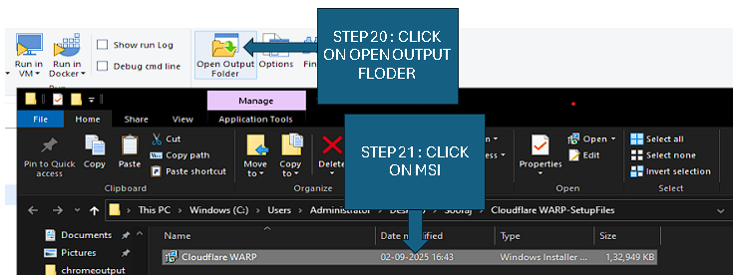

- An "Installation Pop-up" will appear; click "Next" and "Install" until it's done, then click "Finish".

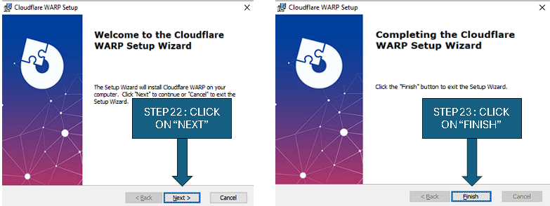
- Check the "Control Panel" to confirm that the software is installed.
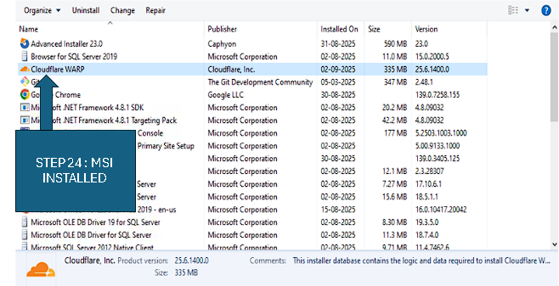
- To test the launch condition, go to the "Launch Conditions" section again and select a random Windows version that is not on your current system.

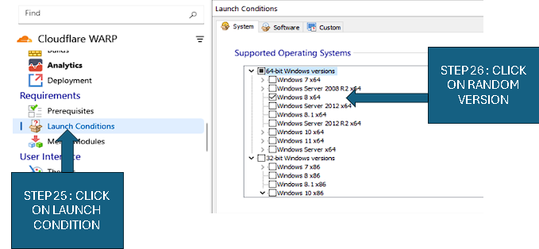
- Go to "Product details" and then "Build".

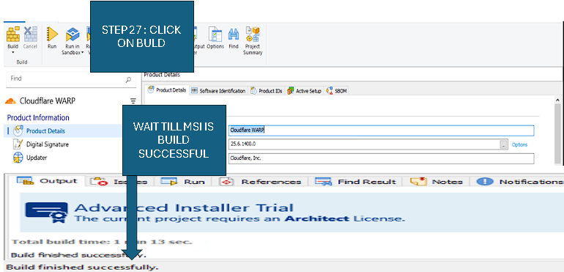
- When you click on the MSI file you just built, an error pop-up message will appear, stating that the application cannot be installed⁵¹. This confirms that your project and the launch condition are successful.
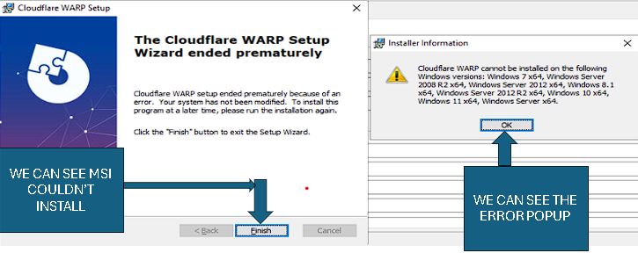

Conclusion
This project successfully used application repackaging to create a smart installer with a launch condition, preventing installation on unsupported operating systems and ensuring a reliable deployment.

Sources and references

https://www.advancedinstaller.com/user-guide/
https://learn.microsoft.com/en-us/windows/win32/msi/launch-conditions

THANK YOU

